Formulae

Let ax + by = c, where a, b are given integers and x, y are
unknown integers. Suppose at least one of a, b is not zero. Then let
g = gcd(a,b). If g does not divide c then there are no solutions to
this problem.

I leave it to you to prove that if x and y have no common factor, then
the diagonal of an x-by-y rectangle intersects x + y - 1 tiles.

For a quadrilateral with sides a, b, c, d, and for which q is half the sum of two opposite angles (it doesn't matter which pair), the area is given by:
A = [(s-a)(s-b)(s-c)(s-d) - abcd cos²q].
For a cyclic quadrilateral, i.e., a quadrilateral that can be inscribed in a circle, and for which the sum of opposite angles is 180°, cos q = 0, thereby maximizing the area.

How many squares are there in a 8 x 8 square?
How many rectangles are there?
Find an equation that will find out the number of squares simply by
knowing the size of the square.

The "equation" must be
N = (9-m)(9-n) where N is the number of rectangles, m is the height of
the rectangle and n is the width of the rectangle.

I hope that this helps

No of squares = Σ n^2 (where n is the dimension of the square)

Circle |  |  | 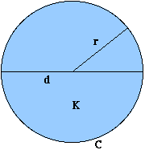
All points on the circumference of a circle
are equidistant from its center.
Radius: r
Diameter: d
Circumference: C
Area: K
d = 2r
C = 2 Pi r = Pi d
K = Pi r² = Pi d²/4
C = 2 sqrt(Pi K)
K = C²/4 Pi = Cr/2
 |  | To read about circles, visit The Geometry Center.

Arc of a Circle |  | 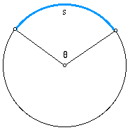
A curved portion of a circle.
Length: s
Central angle:
theta (in radians),
alpha (in degrees)
s = r theta = r alpha Pi/180

Segment of a Circle |  | 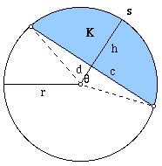
Either of the two regions into which a secant or a chord cuts a circle.
Chord length: c
Height: h
Distance from center of circle to chord's midpoint: d
Central angle: theta (in radians), alpha (in degrees)
Area: K
Arc length: s
theta = 2 arccos(d/r) = 2 arctan(c/(2d)) = 2 arcsin(c/(2r))
h = r - d
c = 2 sqrt(r²-d²) = 2r sin(theta/2) = 2d tan(theta/2) = 2 sqrt[h(2r-h)]
d = sqrt(4r²-c²)/2 = r cos(theta/2) = c cot(theta/2)/2
K = r²[theta-sin(theta)]/2 = r²arccos([r-h]/r) - (r-h)sqrt(2rh-h²)
= r²arccos(d/r) - d sqrt(r²-d²)
theta = s/r
K = r²[s/r - sin(s/r)]/2
For much more about segments of circles, see
The Arc, Chord, Radius, Height, Angle, Apothem, and Area.

Counting Rectangles within Rectangles
Squares
How many squares can be found in the checkerboard shown in the figure, below?
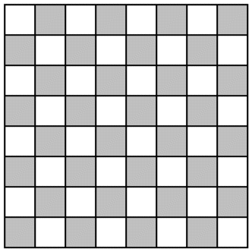
There is one 8x8 square, the outer border of the figure. There are four 7x7 squares, one aligned with each corner. There are nine 6x6 squares, etc. So the sum of the first 8 squares 1+4+9+16+25+36+47+64=204 is the answer. In general, the sum of the first n squares is given by the formula
(2n³+3n²+n)/6
Formulas for sums of the first n numbers of a given power are always polynomials of degree one higher than the given power. For example, the sum of n fourth powers is given by a fifth degree polynomial in n. The Method of Successive Differences can be used to find such polynomials.
Rectangles
Now, how many rectangles can be found within an m x n rectangle?
The answer to this question is the same as the answer to another question:
How many ways can I draw two horizontal lines and two vertical lines through an array of (m+1) by (n+1) dots?
(Think of the dots formed at the corners of the little squares within the rectangle)
The two horizontal lines can be drawn C(m+1,2) ways, and the two vertical lines can be drawn C(n+1,2) ways, so the total number of rectangles within an m x n rectangle is
C(m+1,2) C(n+1,2)
Squares within Rectangles
How many squares can be found within an m x n rectangle? (m > n)
To answer this question, start with an n x n square, and then you know the number of squares in this portion of it from the first section:
(2n³+3n²+n)/6
Now, consider adding one row of squares at the bottom, making it an n+1 by n rectangle. Think of the dots formed at the corners of the little squares you added to make the bottom row. Now, for every pair of newly-added dots, you can find one new square. So the number of new squares you can find in the now larger rectangle is the number of pairs of n+1 dots, which is C(n+1,2). If you need convincing, there's another way to think of it. By adding a new row of n little squares, you can now find within the large rectangle one new n x n square, two new n-1 x n-1 squares, three new n-2 x n-2 squares, etc. So the number of new squares added this way is the sum of the first n counting numbers, which is C(n+1,2).
Now, add another row of squares at the bottom, making it an n+2 by n rectangle. This adds the same number of new squares, C(n+1,2).
Now I'm sure you see the picture. The number of squares that can be found within an m x n rectangle (m > n) is given by this formula:
(2n³+3n²+n)/6 + (m-n) C(n+1,2)

Sector of a Circle |  | 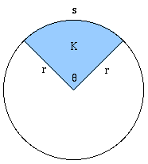
The pie-shaped piece of a circle 'cut out' by two radii.
Central angle:
theta (in radians),
alpha (in degrees)
Area: K
Arc length: s
K = r²theta/2 = r²alpha Pi/360
theta = s/r
K = rs/2

a^p = 1(mod n) where a, n are co-prime and
p is the number less than n co-prime to n.
Thus, 3^144 = 1(mod 1729)
and 2^144 = 1(mod1729)
if n = x*y*z then
co-prime to n and less than n are
n*(1-1/x)*(1-1/y)*(1-1/z)

++++++++++++++++++++++++++++++++++++++++++++++++++++++
When a number is successfully divided by two divisors d₁ and d₂ and two remainders r₁ and r₂ are obtained, the remainder that will be obtained by the product of d₁ and d₂ is given by the relation
d₁r₂ + r₁.
Where d₁ and d₂ are in ascending order respectively and r₁ and r₂ are their respective remainders when they divide the number.

++++++++++++++++++++++++++++++++++++++++++++++++++++

Two numbers when divided by a common divisor, if they leave remainders of x and y and when their sum is divided by the same divisor leaves a remainder of z, the divisor is given by x + y - z.

